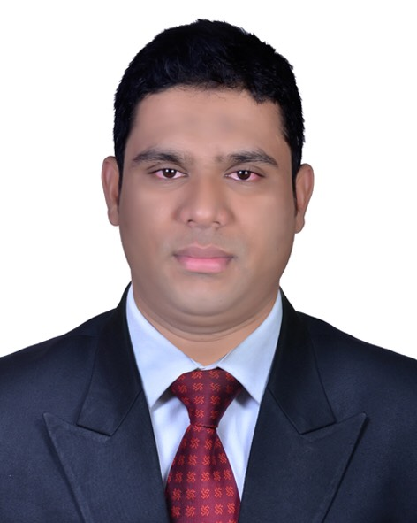

RESUME
RAHMAN, MD. MAHFUZUR
22-26 1st Floor, Bruckner Blvd., Bronx NY 10473
Mobile ::: 001 929 261 8340.
Email : mahfuzadnan.usa@gmail.com

Aptitudes:
Self-Confident.
Highly spirited.
Highly motivated and ability to motivate others.
Ability to convince people.
Honesty and sincerity to work.
Ability to organize and manage.

Academic Records:
Graduations From National University of Bangladesh (2010).
High School Diploma.

Work :

Security Officer (From April 2017 To Present)
Garrisson Protective Service.
MG Security Services.

Heght : 5 Feet 11``

Organisation:::

Charter President (2016-2017)
Rotaract Club Of New York Queens
Spon. By ::: Rotary Club Of Jackson Heights NY,
Rotary International District 7255 USA.

Charter President (2009-2011),
Rotaract Club of Sylhet New City,
Sponsored By : Rotary Club of Sylhet New City
Rotary International District - 3282, Bangladesh.

Languages ::: Bangla, English, Hindi, Urdhu And Nepali.
Computer Skill: Microsoft Word, Internet Browsing.

